Face Recognition Based Smart Door Lock System

Introduction
The Face Recognition Based Door Lock System is an intelligent security system that uses computer vision and machine learning to identify authorized users and automatically unlock a door.

Objectives
- Develop a secure automated door lock system
- Implement real-time face recognition
- Control hardware using software
- Enable remote unlocking
- Create a low-cost solution

Technologies Used
Software: Python, OpenCV, NumPy, Flask, PyFirmata
Hardware: Arduino, Servo Motor, Camera

Project Files
datacollect.py – Dataset collection
trainingdemo.py – Model training
Trainer.yml – Trained model
testmodel.py – Main program
controller.py – Servo control

Working
1. Capture face images
2. Train model using LBPH
3. Detect and recognize faces
4. If recognized → Unlock door
5. Else → Access denied

Door Control
Servo motor rotates to unlock (45°) and lock (0°) using Arduino and PyFirmata.
Circuit Diagram:-
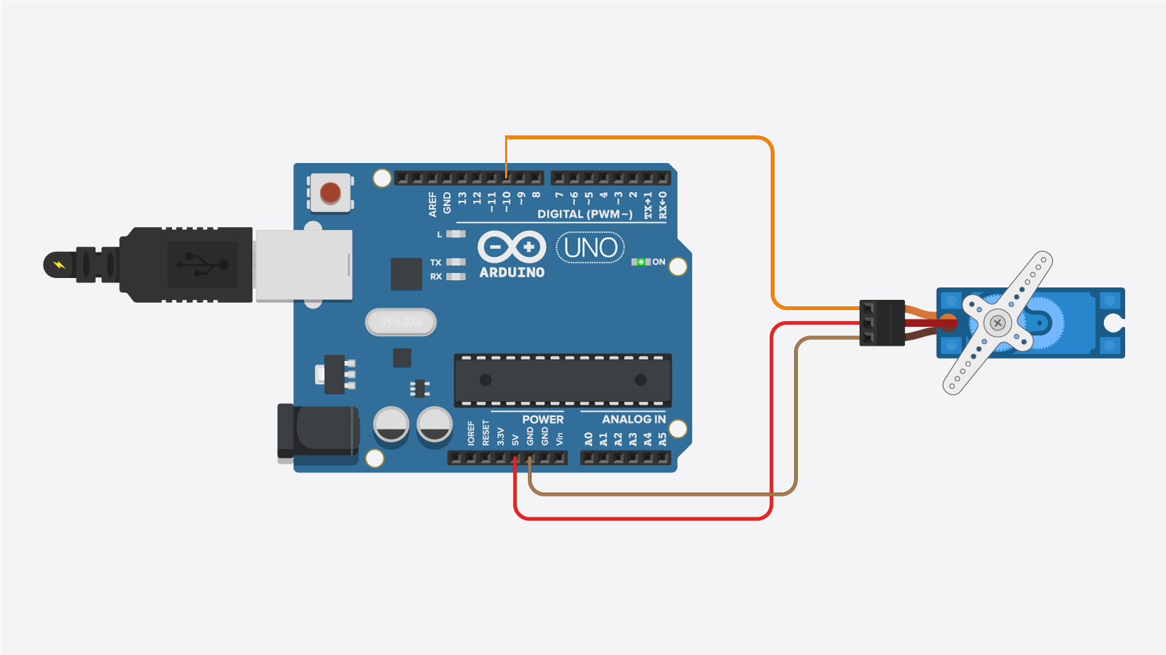

Remote Access
Flask server allows unlocking using URL with a secret key.
When we enter the secret key in the mobile app. After secret key verifying, The door lock is unlocked. Its works with mobile data, wifi, any ip address.

Commands:-
install Python 3.10
pip install opencv-python
pip install pillow
pip uninstall opencv-python -y
pip install opencv-contrib-python
pip install pyfirmata
pip install flask
# Run datacollect.py – Dataset collection
# Run trainingdemo.py – Model training
# testmodel.py – Main program
press "O" on keyboard to unlock
press "q" on keyboard to exit the software

Conclusion
This project demonstrates a smart, automated, and secure door locking system using AI and IoT.

